**Q1: Practical Applications of Ohm’s Law. Explain at least five real-life applications of Ohm’s law.**

**Ans:** Ohm’s Law describes the relation between Voltage , Current and Resistance in a circuit.

1. Voltage is directly proportional to Current keeping resistance constant

2. As current increases resistance also increases when voltage is constant and vice versa.

**I = V**

**R**

Ohm’s law is crucial for developing , understanding and troubleshooting electric circuits. It is used to calculate Voltage , Current and resistances in circuits. It is at foundation of **electrical engineering.**

# Applications of Ohm’s Law:

Here we describe some examples of real life life applications of ohm’s law , how it is used in Household wiring and different home appliances.

* **Home Electrical Wiring:**

Ohm’s Law is applied in household’s electrical wiring. e.g it is used in *fuses.* **Fuses** are electronic devices used to regulate the flow of current in wiring. When the current in the circuit increase fuse , fuse and break the circuit , hence saving the home appliance from getting high voltage. The requirement of its specific resistance is determined by Ohm’s law.

A Fuse

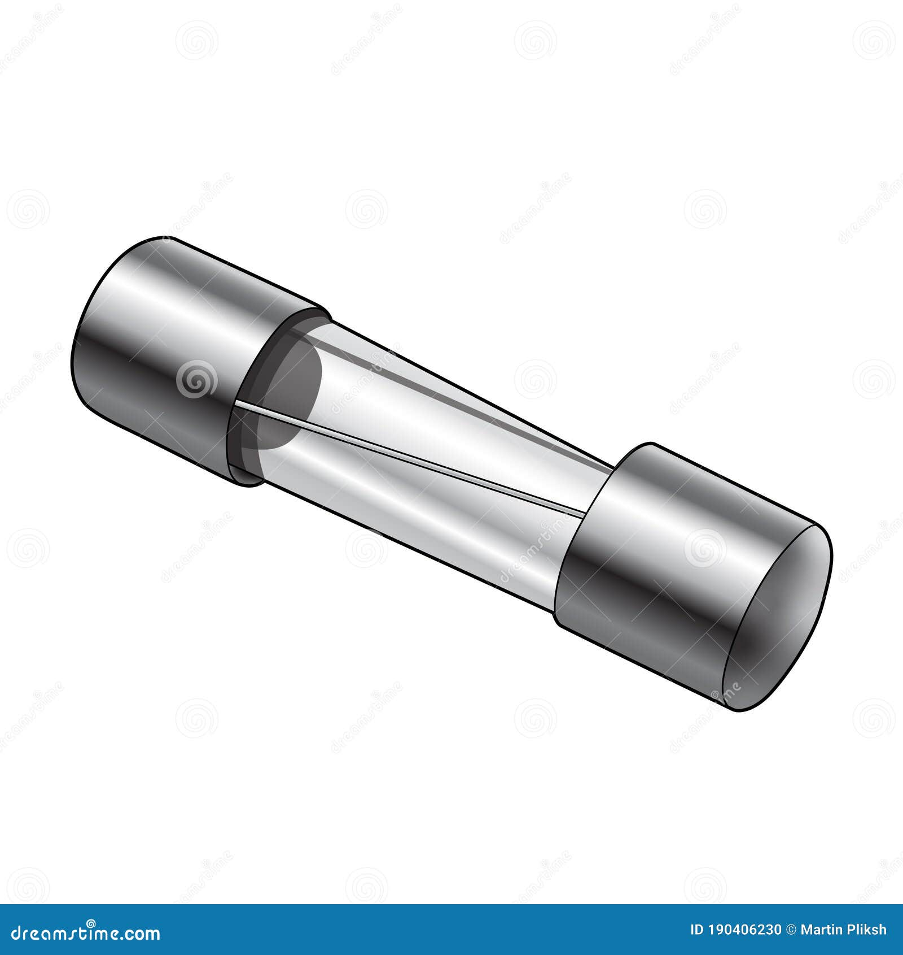

* **Mobile Phone Chargers:**

Mobile Phone and Laptop chargers use DC power supply for charging their relative devices. The working of this supply depends on Ohm’s law. Chargers are to provide a stable voltage output, the **voltage is regulated** based on concepts by Ohm’s law. Current is also controlled in similar manner. It also save devices from overloading.

* **Home Appliances:**

Working of several household appliances is based on Ohm’s law e.g electric heaters , electric kettles and fans.

* + In electric heater , heat is being generated by resistance to current in electric rods. Ohm’s law deals with current and resistance in circuit.
  + In electric fans , the speed of fan is adjusted by a regulator , Regulator adjust the speed of fan **by regulating the flow of current in circuit** which is in turn regulating by controlling resistance.
  + Electric kettles consists of multiple resistances inside them , which generates heat.
* **Automotive Circuits:**

In automotive circuits , Ohm’s law is applied to diagnose faults and understand circuit behaviour , it allows technicians to calculate unknown values when others are known. For example one way to find a fault in car’s circuit is by *Voltage drop testing*  , the value of voltage or current is calculated by using Ohm’s law.

The **starter motor** requires high current (100A–200A) to crank the engine. Using Ohm’s Law, engineers calculate the **correct wire thickness** to handle the current without excessive resistance (which could cause heat and power loss). Spark plug voltage is stepped up to **thousands of volts** by the ignition coil based on **resistance values in the circuit**.

* **Light Emitting Diode (LED’s):**

Though LED’s are not fully ohmic devices , but ohm’s law is still an important tool for designing LED circuits. Ohm’s law is used to calculate

the right resistance needed in an LED circuit to limit current and prevent damage , resistance is found by subtracting the forward voltage (the resistance across them when conducting) of LED’s from the supply voltage and then applying Ohm’s law to **find the resistance**.

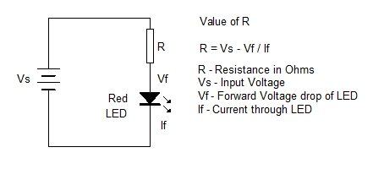

Figure 1: Resistances in a LED

**Conclusion:**

Ohm’s law is stated to tell the relation between current and voltage in an electric circuit . Ohm’s law was named after the German physicist , **George Ohm.** Today , as we have seen Ohm law have variety of applications. Some main applications include calculating current , voltage , resistor among the circuit and to simplify calculations involving power.

**Q2: Discuss the various factors that influence Ohm’s law in electrical circuits.**

**Ans:** Ohm’s law is influenced by multiple factors , major factors are temperature , material of the conductor , cross sectional area and length of wire. Almost all these factors influence resistance of the circuit hence affecting Ohm’s Law. Some other factors are external magnetic fields and frequency of AC Voltage , below all these factors and their influences are discussed in detail.

**Temperature and its effect on resistance:**

Resistance is **directly proportional** to temperature, as the temperature of the circuits increase the resistance also increase and vice versa. The increase in the temperature cause the atoms in the wire to vibrate more violently , causing more hindrance in the flow of electrons hence increasing the resistance. As resistance increases the current decreases, affecting the Ohm’s Law.

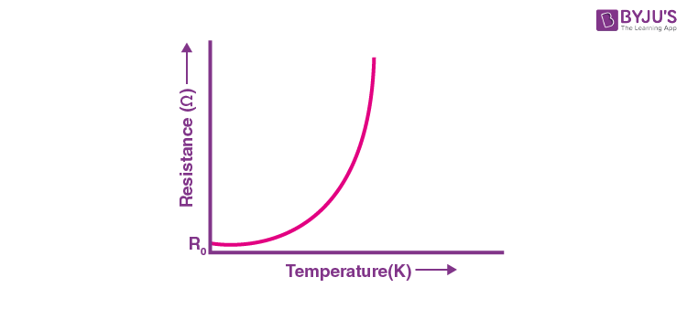

**Material of the Conductor:**

The resistance of the circuit is also dependent on the material used in the wire. Different materials have different **resistivity** – resistance per unit length or cross-sectional area of the conductor. Resistivity is the characteristic property of every material. Materials with high resistivity have large resistance and with low resistivity e.g copper have low resistances.

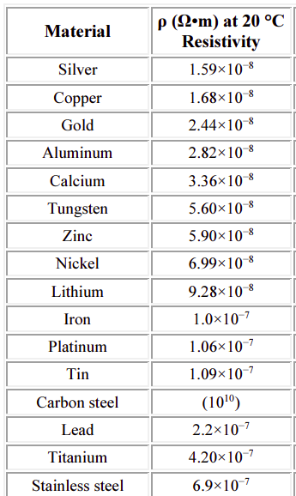Table 1: A table of resistivities of different materials at 20 degree C.

**Cross Sectional Area and Length of the Wire:**

The resistance of a wire is inversely proportional to the cross sectional area of the wire. Conductors with large cross sectional area would have low resistances and vice versa.

Resistance of wire is directly proportional to its length , long wires have more resistance and small wires have low resistance.

The relationship between resistance of wire and its cross sectional area and length is given by the following formula:

**R = (ρ * L) / A**

where ρ is the resistivity of the material , L is the length of the wire and A is the cross sectional area.

**External Magnetic Fields and Frequency of AC Voltage:**

External magnetic fields can affect Ohm’s Law , when a conductor is moving or when the magnetic field is changing around the conductor , it affect Ohm’s Law by inducing an additional force known as **Lorentz Force** , on the charge carriers and potentially altering the current flow.

The varying frequency of AC Voltage alters the **impedence** – *the opposition to Alternating Current in circuits by different components –* of the circuit hence changing the current and affecting Ohm’s Law.

**Nature of the Current:**

The resistance also depends on nature of the current flowing through wire. Alternating Current (AC) and Direct Current (DC) have different effects on resistance of the wire .